**Sound Snake**

**Guide**

Edited by

Ben DeSouza,

Natalie Brady

& Shanice Carew

**Context**

1. Step-By-Step Game Play 3

2. Arduino Setup 4

3. Raspberry Pi Setup 5

3.1. Processing onto Raspberry Pi Script 6

4. Processing & Arduino code 7 - 18

**Step-By-Step Game Play**

Sound Snake is a game concept where the player maneuvers the snake around a grid to collect apples. The aim of the game is to collect as many apples as you can without bumping into the edge of the grid or the snake’s body itself.

Use SOUND to control the snake.

Clap, shout, stamp or even scream at the:

Left mic to move the snake left ⇦

Right mic to move the snake right ⇨

Top mic to move the snake up ⇧

Bottom mic to move the snake down ⇩

Bump into the edge of the grid, or your own tail and it’s Game Over!

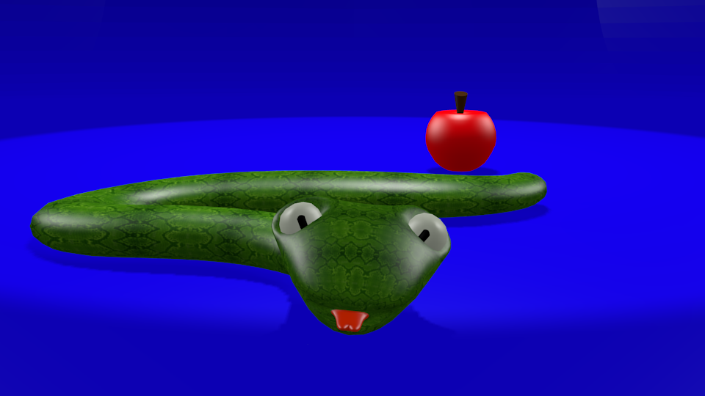

Natalie Brady

1. **Arduino Setup**



Our Arduino takes our input which is sound picked up by our microphone, and outputs it as code to be read by our game in processing.

**Arduino Ports**

A0-A5 – Input

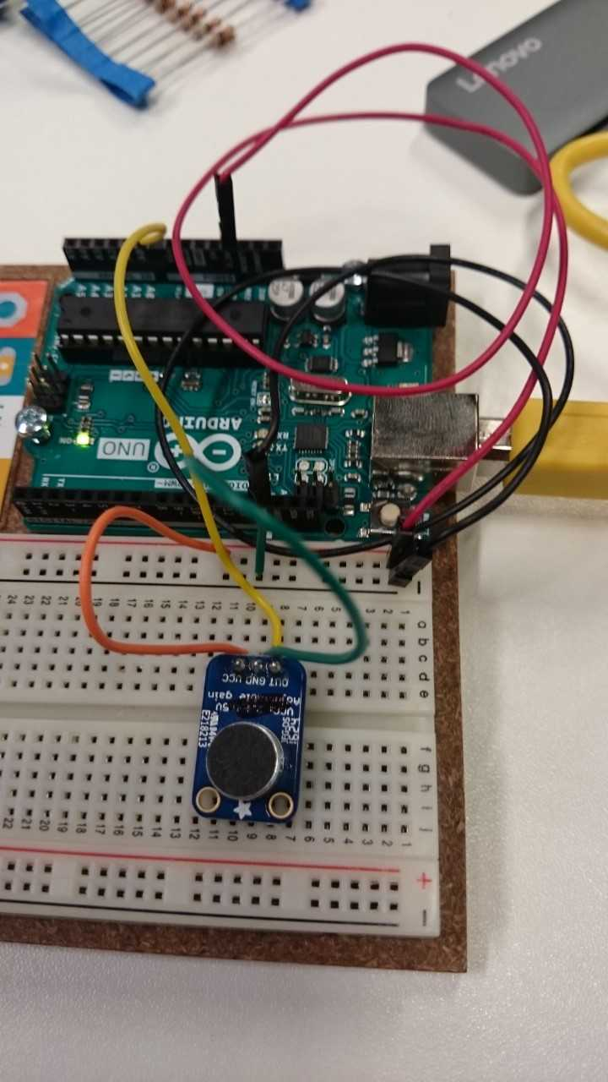GND - Ground

3.3V, 5V – Voltage

**Input Configuration**

A0 – Down (Print: S)  
A1 – Up (Print: W)

A2 – Left (Print A)

A3 – Right (Print D)

Keys are assigned functions in processing (in this case, WASD), then the keys are mapped onto microphones.

**Microphone Ports**

OUT - Output

GND - Ground  
VCC - Voltage

**Connections**

Microphone OUT to A1/2/3/4.

Mic GND to. breadboard – then - into Arduino GND. Mic VCC into breadboard + and + into Arduino 3.3V creates a circuit between microphone and Arduino board. Repeat for each microphone.

Natalie Brady

1. **Raspberry Pi Setup**



Sound Snake is built on Processing which then can be downloaded onto a Raspberry Pi - which then can be used as a portable setup, that is compact and affordable, an alternative way of running the game. Raspberry Pi cannot run 3D animation/images – an alternative is on a Mac pc.

Steps:

* 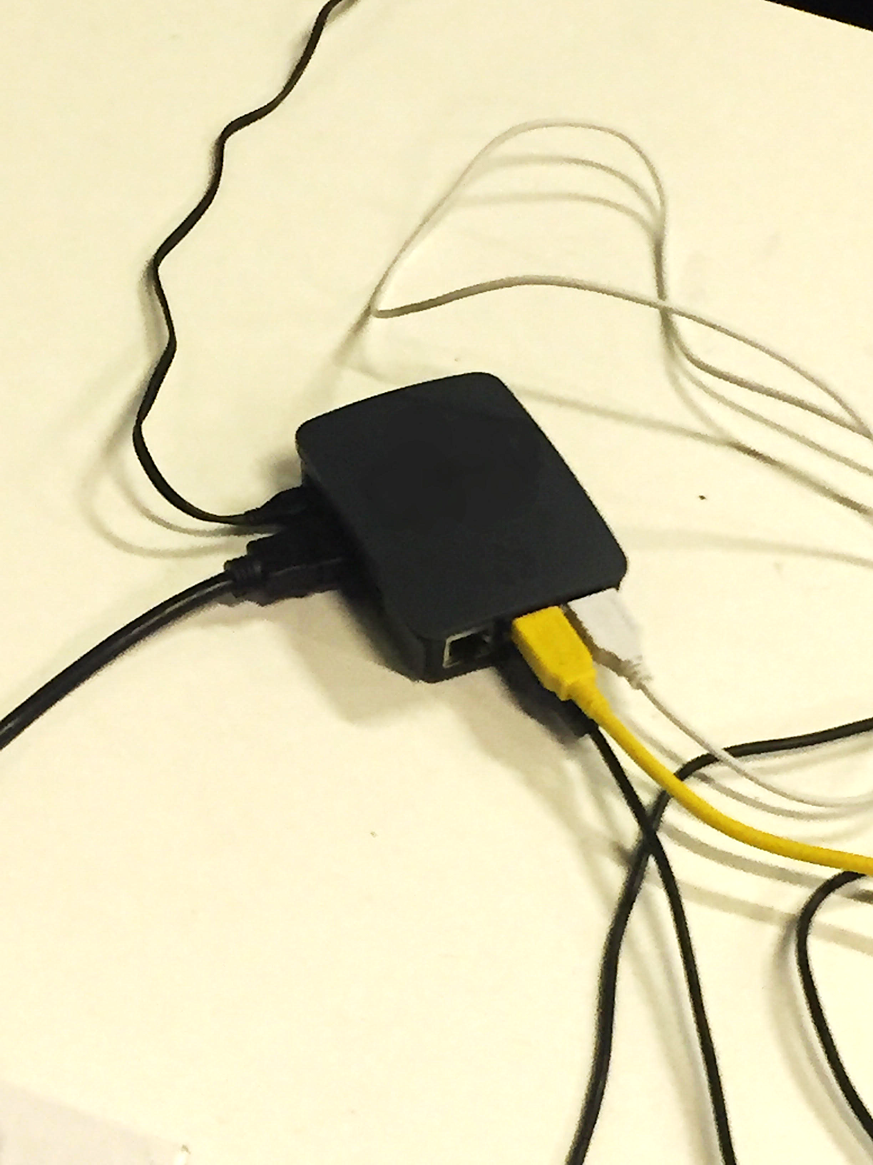**Setup Raspbian** – Can be downloaded with NOOBS or Raspbian image both available online at raspberrypi.org with installation guide.
* **Install Processing** by running script onto terminal (*pg 6*).
* **Setup GPU memory limit**
* **Setup Serial**

Download Sound Snake on Raspberry Pi. Enjoy!

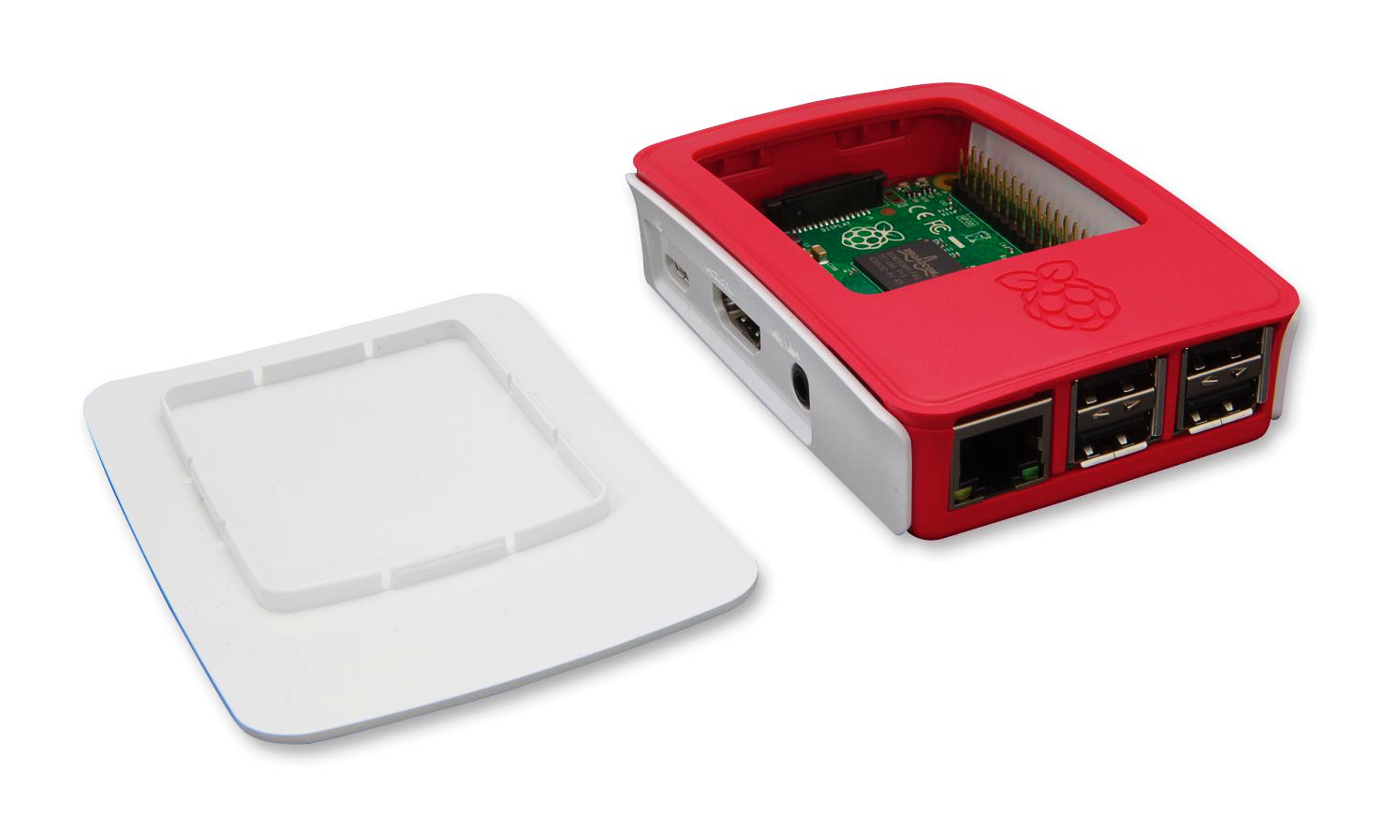

Shanice Carew

**3.1. Processing onto Raspberry Pi Script**



Install Processing by running script into terminal:

*curl*[*https://processing.org/download/install-arm.sh*](https://processing.org/download/install-arm.sh)*| sudo sh*

#!/bin/sh

# This script installs the latest version of Processing for ARM into /usr/local/lib

# Run it like this: "curl https://processing.org/download/install-arm.sh | sudo sh"

# check if on a 64-bit operating system

case "$(file $(which file))" in

*aarch64*) FLAVOR="arm64"; TAR="$(curl -sL https://api.github.com/repos/processing/processing/releases | grep -oh -m 1 'https.*linux-arm64.tgz')" ;;

*) FLAVOR="armv6hf"; TAR="$(curl -sL https://api.github.com/repos/processing/processing/releases | grep -oh -m 1 'https.*linux-armv6hf.tgz')" ;;

esac

echo ""

echo "Downloading $TAR..."

curl -L $TAR > processing-linux-$FLAVOR-latest.tgz

echo "Installing in /usr/local..."

tar fx processing-linux-$FLAVOR-latest.tgz -C /usr/local/lib

rm -f processing-linux-$FLAVOR-latest.tgz

# this returns the highest version installed

VER="$(basename $(ls -dvr /usr/local/lib/processing-* | head -1))"

# symlink target might be a directory, replace

rm -rf /usr/local/lib/processing

ln -s $VER /usr/local/lib/processing

# this assumes that /usr/local/bin is in $PATH

ln -sf ../lib/processing/processing /usr/local/bin/processing

ln -sf ../lib/processing/processing-java /usr/local/bin/processing-java

# this assumes that the desktop manager picks up .desktop files in /usr/local/share/applications

mkdir -p /usr/local/share/applications

curl -sL https://raw.githubusercontent.com/processing/processing/master/build/linux/processing.desktop > /usr/local/share/applications/processing.desktop

sed -i "s/@version@/$VER/" /usr/local/share/applications/processing.desktop

sed -i 's|/opt/processing|/usr/local/lib/processing|' /usr/local/share/applications/processing.desktop

# silence validation errors

desktop-file-install /usr/local/share/applications/processing.desktop >/dev/null 2>&1

echo "Done! You can start Processing by running processing in the terminal, or through the applications menu (might require a restart)."

echo ""

**4. Processing and Arduino Code**

**Important Note:** Be sure to enter the code **exactly** how the images display (with the exception of ‘//’ comments), otherwise the game will miss crucial components!

**1: Basic Game Setup**

**Array Lists & Ints**

To begin with, enter the following lines of code at the top of the Processing file. The ‘ArrayList<Integer>’ codes creates references that enable a starting position for the Snake on the board on the ‘X’ and ‘Y’ axis to be done in the code using ‘x’ and ‘y’, the first ‘int’ code line creates the board and the apples and the final ‘int[]’ code line creates the available movements the snake can make along the ‘X’ and ‘Y’ axis. The ‘int score’ code will create a global variable to create a score, the Boolean for ‘gameover’ will create a reference to create scenarios to end the game and ‘int newdir;’ is the global variable for a new direction.

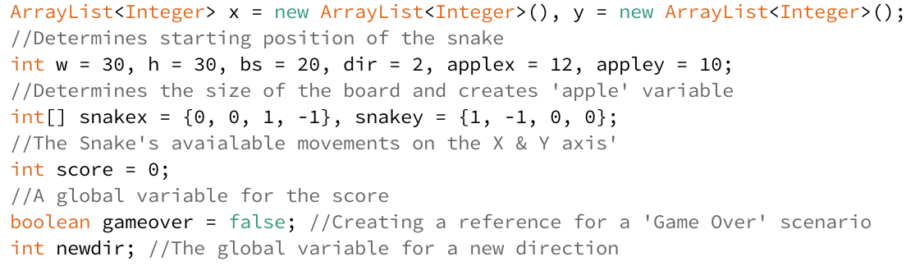

**Void Setup**

Underneath the ‘int[]’ line of code, create a ‘void setup()’ code if one has not already been generated and input the following lines of code. The ‘size’ code is the properties of the board ‘size(width and height)’ and the ‘x.add’ and ‘y.add’ determine the starting position of the Snake on the board. It is **crucial** that both the ‘x.add’ and y.add’ **numbers are the same!** Be sure to close this code with a **‘}’** or the set up will not be recognised.

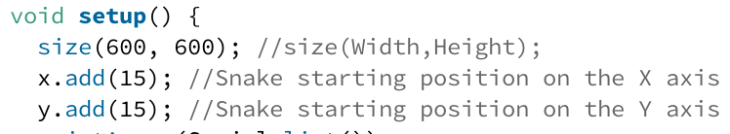

**Void Draw**

Create a ‘void draw()’ code and enter these lines of code. The ‘background(R,G,B);’ code creates a background colour and the colour will change depending on the numbers you insert, in this case it is a blue with a slight redness to it. The ‘drawGrid();’ draws a grid on the board, but won’t work without creating ‘void drawgrid()’ in the code. The ‘text(score, 20, 60);’ and ‘textSize(32);’ are all crucial properties to display the score on screen.

The ‘for’ code determines the properties of the snake, including the body ‘(int I = 0; I <x.size(); i++)’, the colour green ‘fill(0,255,0);’ and the shape to be a rectangle ‘rect(x.get(i)*bs, y.get(i)*bs, bs,bs.’

The first ‘if’ lines of code creates a scenario where the game does not end, otherwise the game will be stuck in ‘game-over.’ Underneath are the ‘fill’ and ‘rect’ lines of code which are the design properties of the apple to be a red rectangle in any given axis. The second ‘if’ lines of code determine the movement properties of the Snake including: the speed ‘(frameCount%5==0)’ and the movements on the ‘X’ axis ‘x.add(0, x.get(0) + snakex[dir]);’ and ‘Y’ axis ‘y.add(0, y.get(0) + snakex[dir]);’.



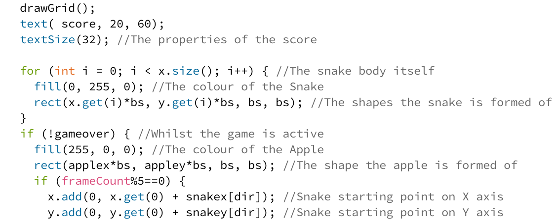

Underneath, insert these lines of code which determine what triggers ‘game-over’ scenarios. The ‘if’ line of code determine that of any part of the snake hits the boundaries of the game board then it will spell game over. The ‘for’ line of code determines that if any part of the snake hits itself then it will also spell game over.



Underneath the game over codes, insert these lines of code which determines what happens if the Snake eats the apple. The ‘if’ line of code generates a growth in the Snake if the Snake eats the apple. The ‘applex’ and ‘appley’ codes state that if the Snake eats the apple, they will be generating at any random point on the grid. The ‘score++;’ code enables the score to go up by 1 every time an apple is eaten.

The ‘else’ lines of code stop the snake from automatically growing on its own whilst it also enables the snake to move on its own when the player hasn’t made a movement action.

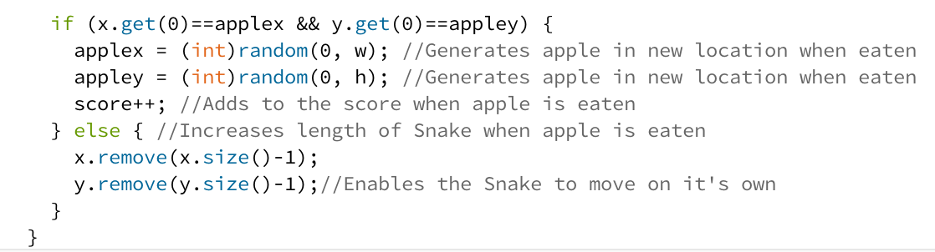

Below this, insert these lines of code which determine what happens in the ‘game-over’ scenario. It’s important the background remains the same as the playing board to maintain consistency. The ‘textAlign(CENTER)’ to ‘text(“YOU SCORED:”, 300, 540);’ are the properties needed to display the game-over message. The ‘text(score, 300, 570);’ will display the final score you got whilst playing the game.

The ‘if’ lines of code gives the option to reset the game when the spacebar is pressed. It clears the board on the ‘X’ axis and ‘Y’ axis, starts the Snake in its original starting place and resets the score to 0. The main key in resetting the game is the ‘gameover = false;’ code.

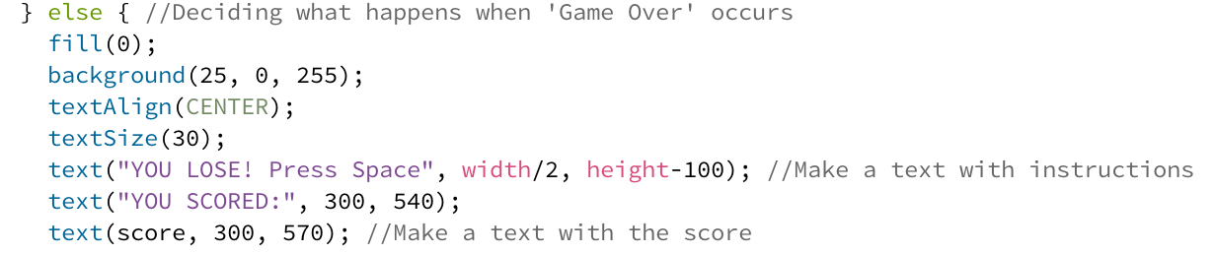

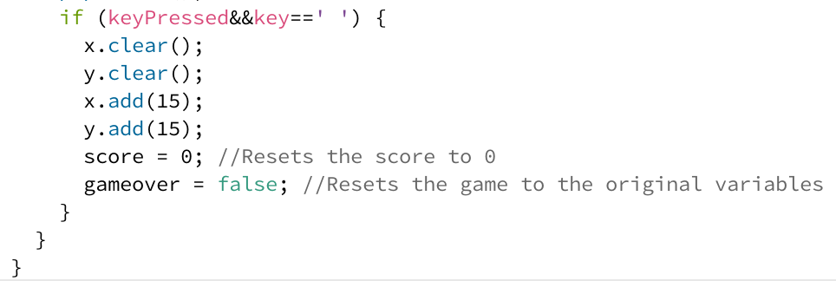

**Void Draw Grid**

Earlier in the code, a variable called ‘voiddrawGrid()’ was inserted under ‘void draw’ which is designed to draw a grid, but won’t work unless a ‘voiddrawGrid()’ variable was created.



Underneath the ‘game-over’ code, create ‘void drawGrid()’ and insert these lines of code. Both ‘for’ codes will generate lines, the first ‘for’ line of code creates vertical lines and the second ‘for’ code creates horizontal lines. When the ‘void drawGrid()’ is used now, a grid will show whilst playing the game.

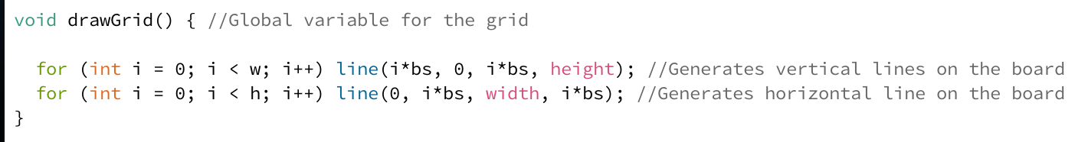

**Void Check Snake**

Underneath the ‘void drawGrid()’ code, create another variable called ‘void checksnake()’ and enter these lines of code. This is crucial to stop the Snake moving back into itself unless their snake hasn’t grown yet. If the Snake is going down, it can’t go immediately up and if the Snake is going up, it can’t go immediately down. These same principles apply for if the Snake was going either left or right. By making this line of code into a global variable, it can be easily used later.



**Void Key Pressed**

Underneath, create a ‘void keyPressed()’ and insert these lines of code. This will determine the available controls. The ‘newdir=-1;’ starts the Snake in an automatic direction when the game is launched. The ‘switch (key)’ enables keys to be assigned so if pressed, they will trigger a direction.

The controls are assigned to the ‘WASD’ format and providing everything is entered as it should be, the game will work whether caps lock is on or not. At the bottom of the code, insert the ‘void checksnake()’ global variable as the image shows to that the functions of the Snake not going back into itself made earlier can be recognised.

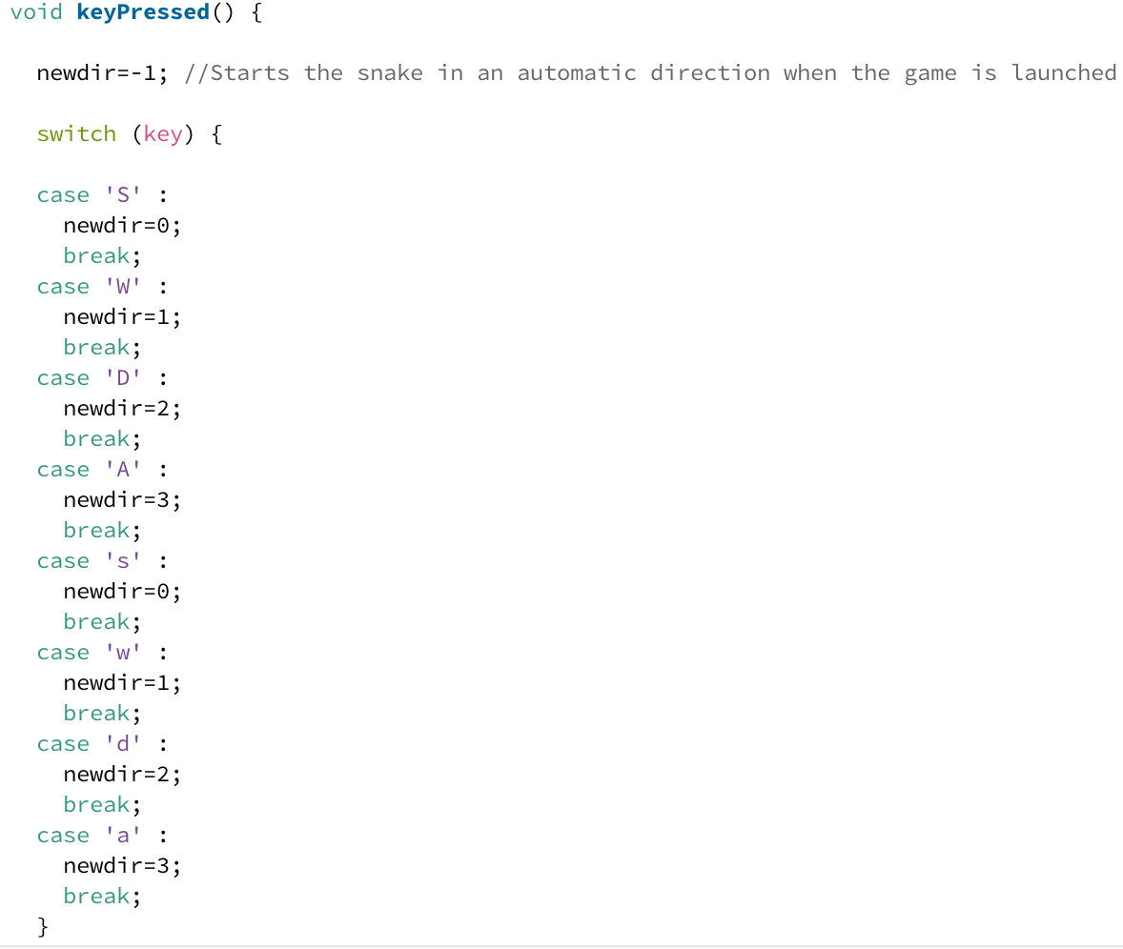

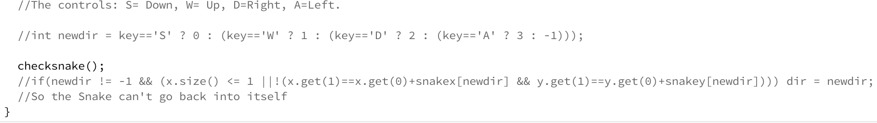

**2: Adding 3D Snake**

**File Adding**

These files must be dragged and dropped into the Processing sketch in order for the image to be properly loaded. Providing this is done, the 3D image can be loaded.

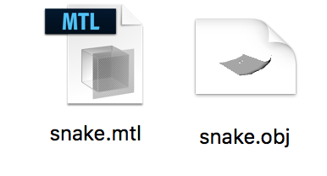

Once completed, go back up to the block of code containing the ‘ArrayList’ and various ‘int’ codes and add the ‘PShape snake;’ code at the bottom.

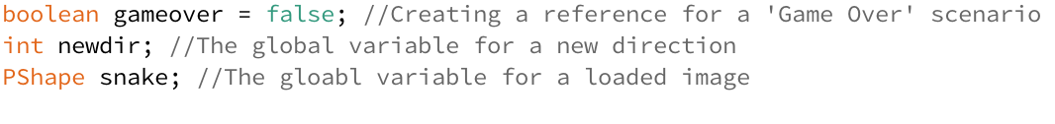

**Void Setup**

Return to the ‘void setup()’ block of code. In the ‘size’ code, add ‘P3D’ so the code recognises it is loading a 3D image, then and add the ‘snake = loadShape(“snake.obj”);’ and ‘snake.scale(65.2)’ lines of code. These are the properties for the 3D Snake. It is particularly crucial you spell out the ‘obj’ file correctly and include ‘P3D’ or the image **will not load!**

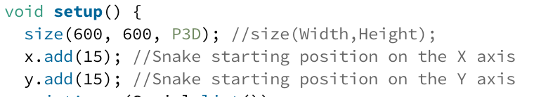

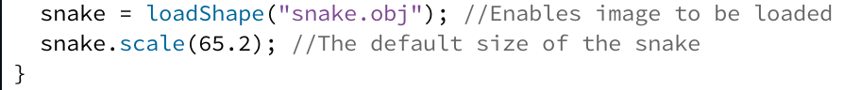

**Void Draw**

At the beginning block of the ‘void draw()’ code, insert the ‘lights();’ line of code. This line of code provides a lighting to the 3D object, meaning the 3D Snake will not appear dark and dull.

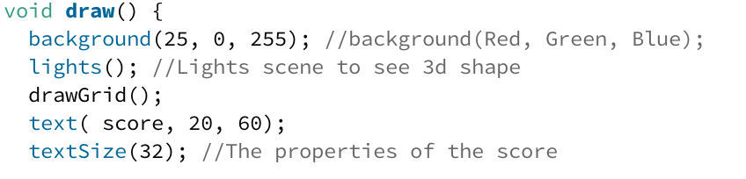

Within the block of code which determines the ‘game-over’ scenario, insert the lines of code from ‘pushMatrix();’ to ‘popMatrix();’. This will load the 3D Snake when the game has ended as set up in ‘void setup()’ and on the ‘PShape = snake;’ code.

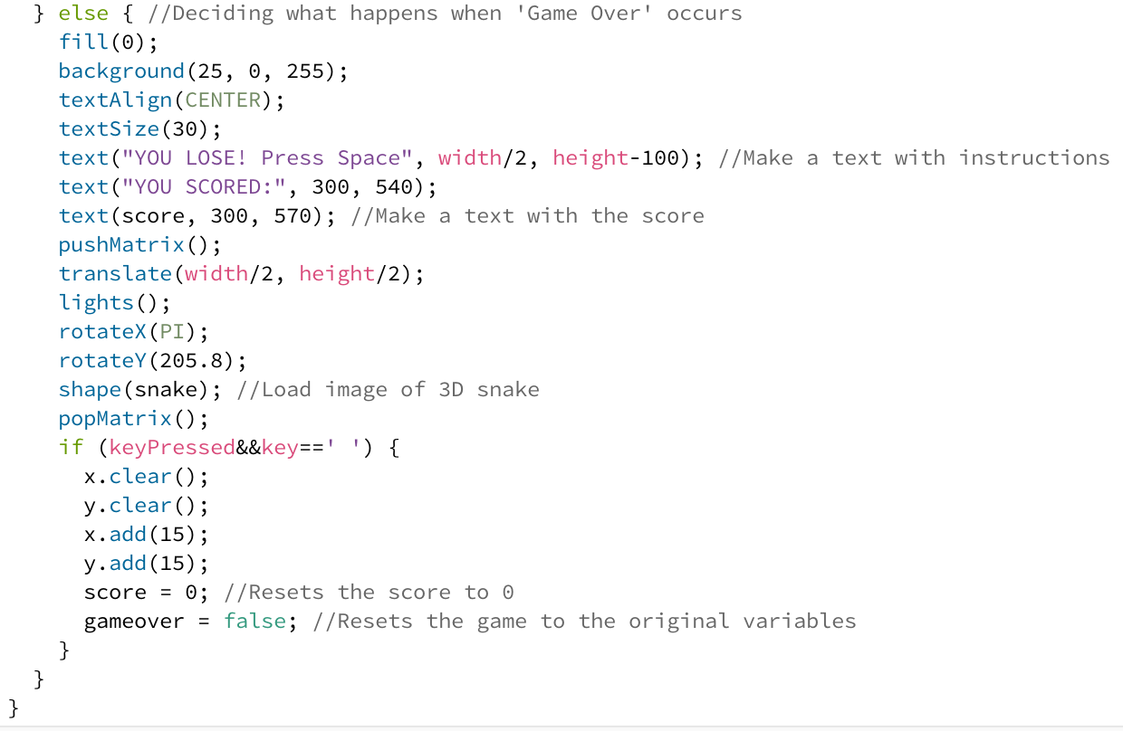

**3: Arduino Code Setup**

**Void Set Up**

After the Arduino board itself has been setup, the code in Arduino must then be set up for the controls of sound to function properly. The following lines is to enable recognition of a microphone inserted in the Arduino and that so that it can be later imported into Processing as a ‘serial input.’

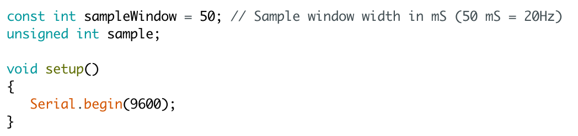

**Void Loop**

Underneath the ‘void setup()’ code, create a ‘void loop()’ code and insert the following lines of code. The first ‘unsigned’ lines of code set up the microphone to recognise values and the second lines of ‘unsigned’ lines of code are both the minimum and maximum values the microphones can receive.

The next block of code between starting at ‘while (millis() – startMillis< sampleWindow) and ending at ‘double volts = (peakToPeak * 3.3)/1024’ sets up the microphone that is plugged into port ‘A0’ to receive anything between the minimum and maximum values depending on the sound.

The ‘Serial.print’ blocks of code enables a letter ‘S’ to be processed when the sound signal is received, which is the equivalent to the ‘down’ key in the ‘Sound Snake’ game.

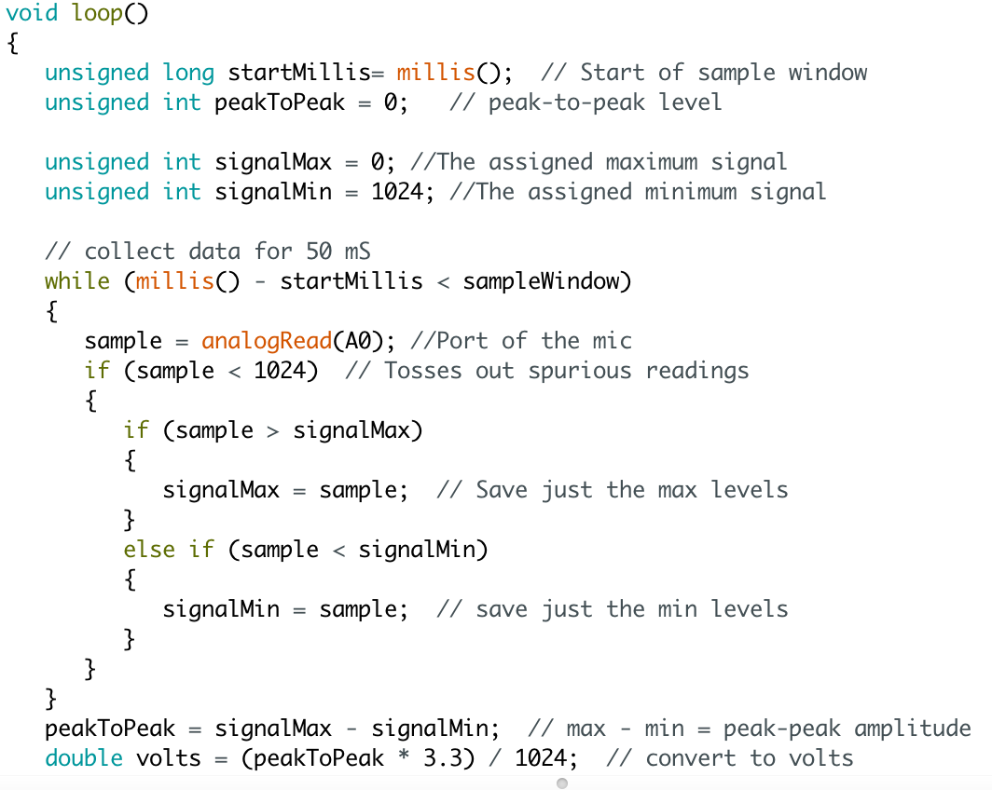

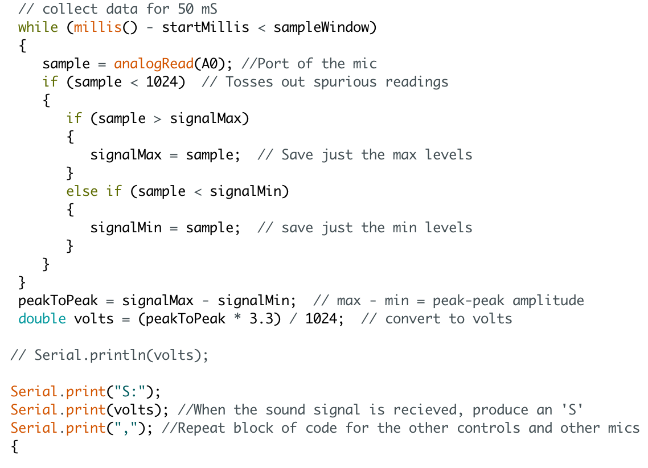

Repeat this block of code again right below, but change ‘A0’ to ‘A1’ and change the ‘S’ to a ‘W’. This is the equivalent to the ‘up’ function in Sound Snake.

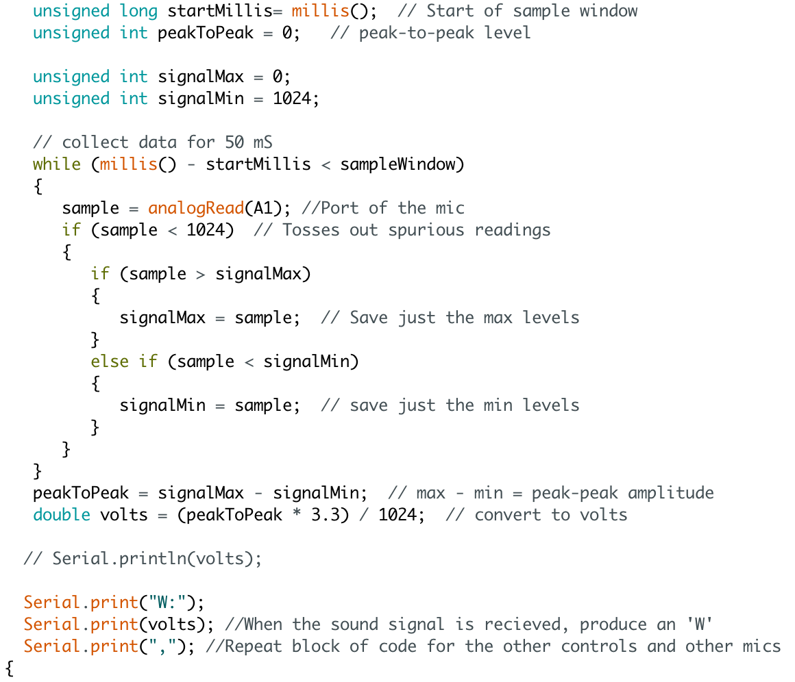

Repeat this block of code again right below, but change ‘A1’ to ‘A2’ and change the ‘W’ to a ‘A’. This is the equivalent to the ‘left’ function in Sound Snake.

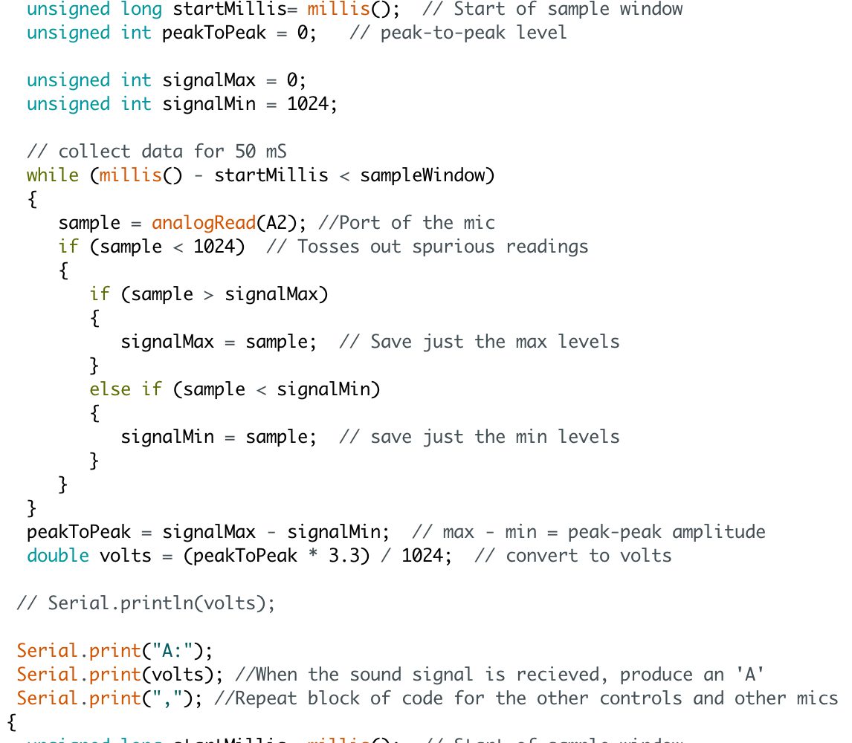

Repeat the code one last time but change ‘A2’ to ‘A3’, change the ‘A’ to a ‘D’ and be sure to add the 4 brackets to end the code. The ‘D’ is the equivalent of the ‘right’ function in the Sound Snake game.

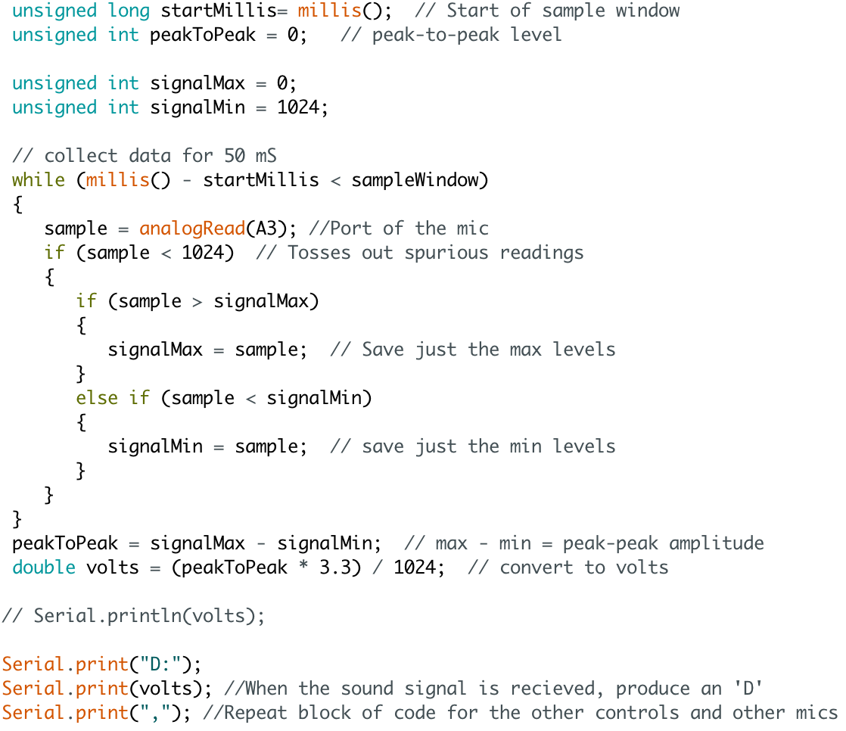

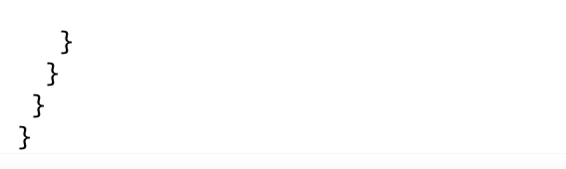

Be sure to test the microphones run correctly. Press the ‘right’ arrow to upload the code and then press the serial monitor (the magnifying glass) to view the data. It should show the letters that have been assigned in the Arduino code.

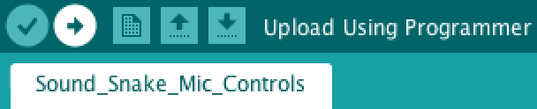



**4: Importing The Arduino Functions**

With the Arduino code uploaded and the Arduino board plugged in, import the serial by going to ‘Sketch/Import Library/Serial’ so that the Arduino code and board can both be recognised as a control in the Processing sketch. The evidence should appear at the top of the code.

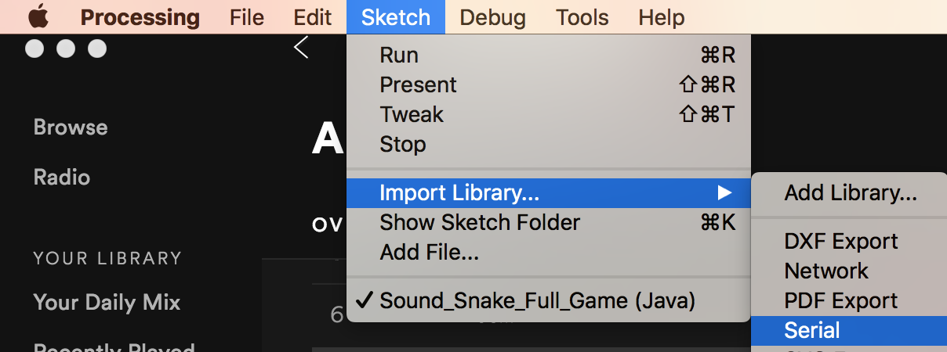

Once done, place ‘Serial myPort;’ below to be the global variable for referencing a port.

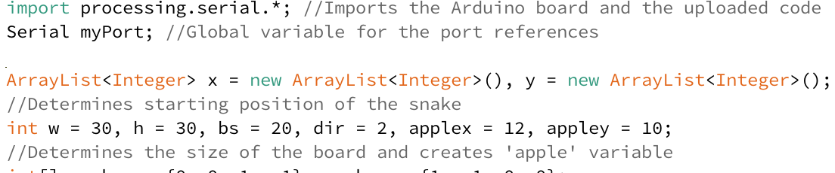

**Void Setup**

Within the ‘void setup()’ code, insert the additional code between the ‘y.add(15);’ code and the ‘snake =loadShape(“snake.obj”);’ code. This code will include the Arduino code and board in the setup of the game.

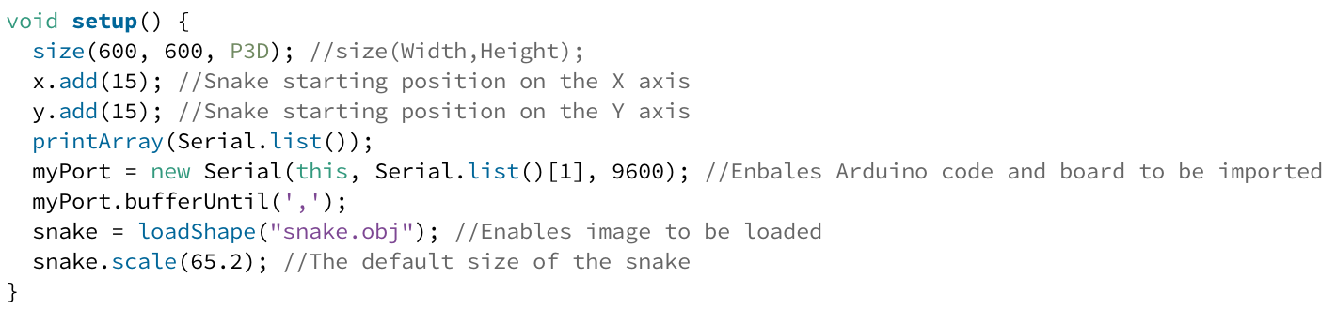

**Note:** In the ‘myPort = new Serial(this, Serial.list()[1], 9600);’, the number inside the [] can vary depending on the computer that is being used. The available numbers to choose from are available in the ‘Console’ when the game is run.

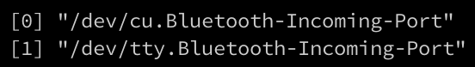

**Void Serial Event**

Between the ‘void drawGrid()’ and ‘void checksnake()’ blocks of code, insert a new global variable called ‘void serialEvent (Serial myPort) and insert the following code. This is the final step in importing the Arduino data

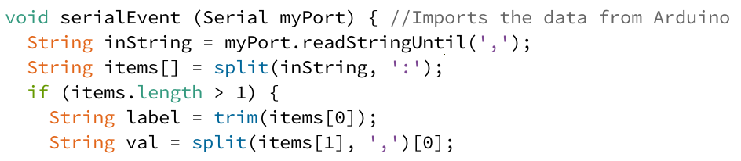

Insert the following code. The code from the Arduino is already set so that each microphone generates a different letter when it receives sound data, all that is left is to assign the directions. The ‘println(val);’ code enables a letter to be generated. The ‘if (float(val) > 0.3)’ code determines that if the data received is greater than a sensitivity ‘0.3’ then the assigned action will occur. The ‘if (label.equals(“”))’ sets up a scenario for what would happen if a character inside the speech marks gets generated.

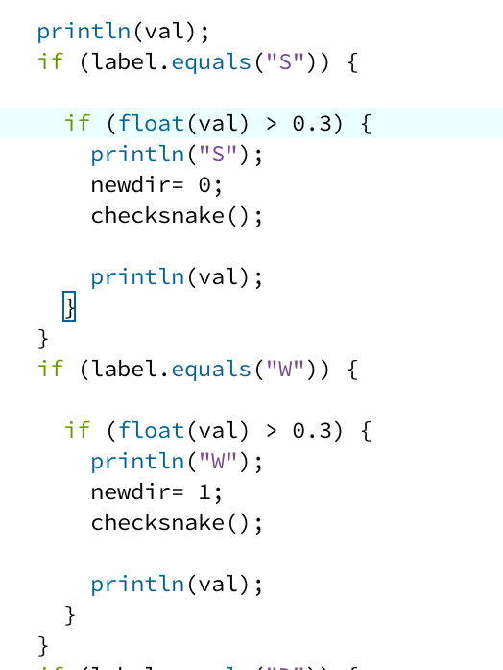

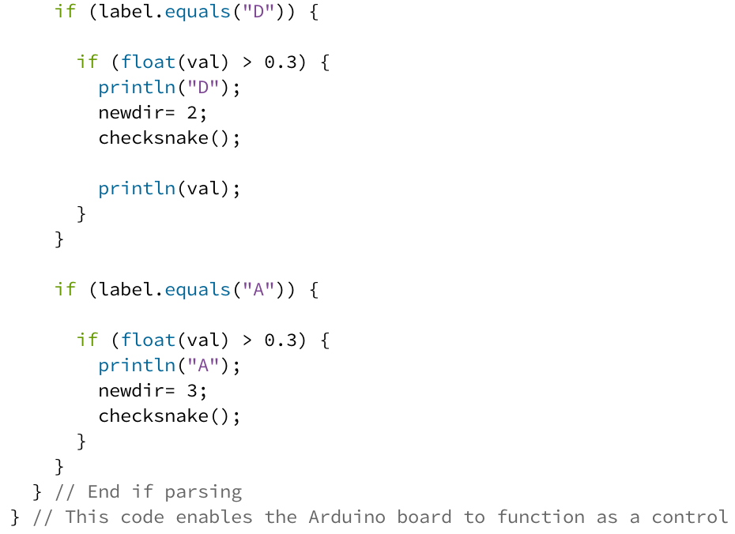

It is crucial that the ‘newdir=’ code has the same number that is assigned to the letter in ‘void keypressed()’ so the ‘WASD’ format is acheived and that ‘checksnake();’ is included after the ‘newdir=’ code so that no movement can cause the Snake to go back into itself.

**5: Testing**

Providing the instructions where followed, the game board should and game over screen should look as follows:

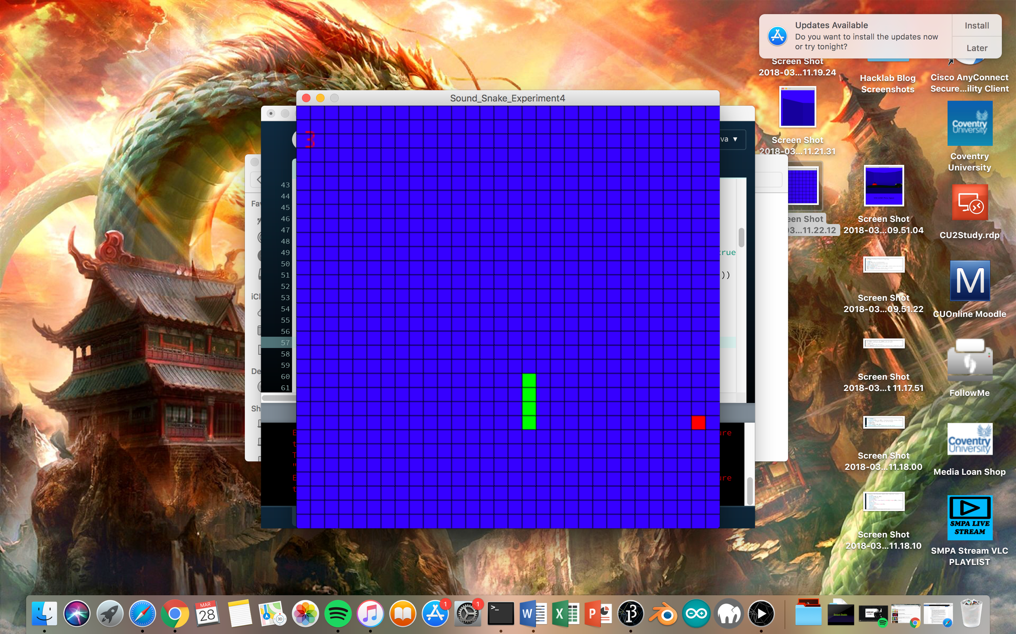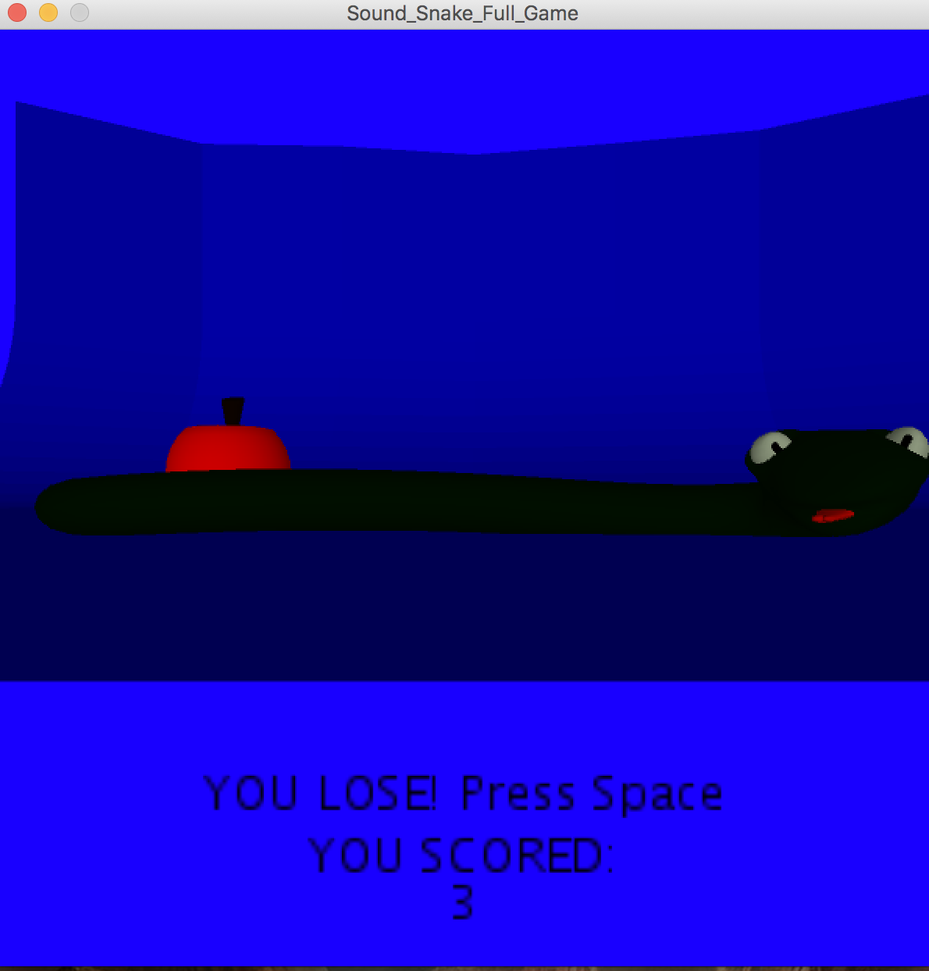

In addition, the microphones should work as controls and the game should function as coded.